Name = Rajesh Nahak, Reg No= 12216196

Roll No= 9 , Section= K22CG

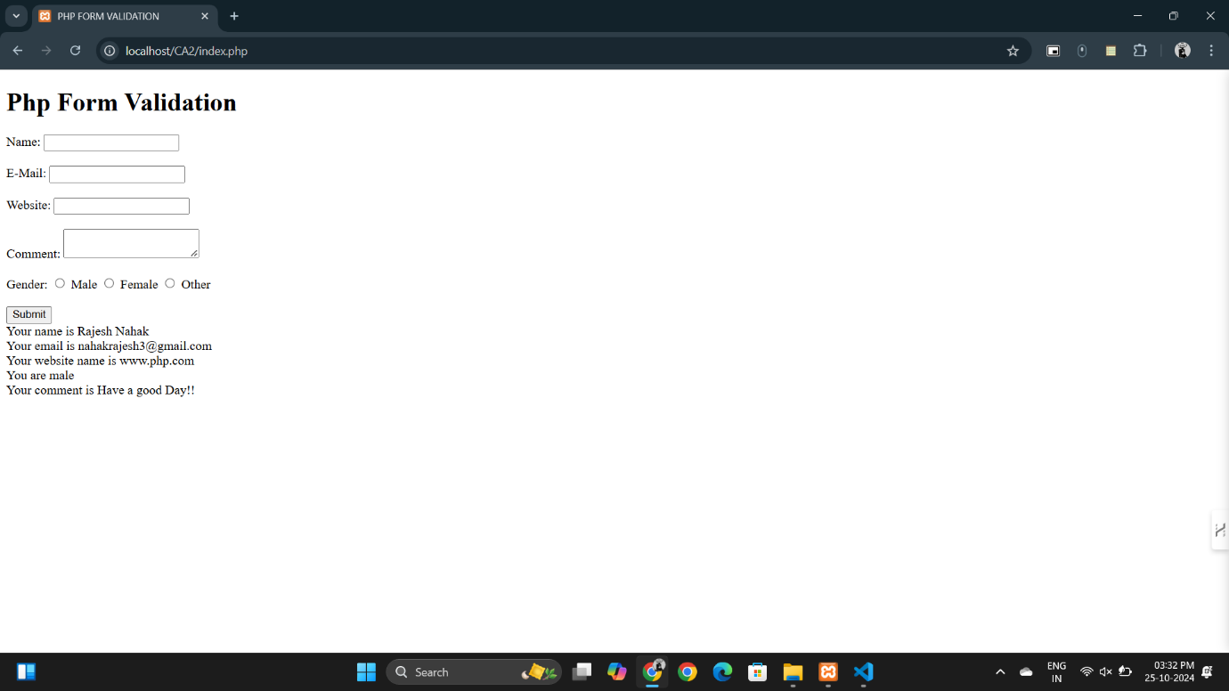

Index.php :-

<!DOCTYPE html>

<html lang="en">

<head>

  <meta charset="UTF-8">

  <meta name="viewport" content="width=device-width, initial-scale=1.0">

  <title>PHP FORM VALIDATION</title>

</head>

<body>

*<!-- Code By Rajesh Nahak -->*

  <h1>Php Form Validation</h1>

  <form action="index.php" method="post">

    Name: <input type="text" name="name" ><br><br>

    E-Mail: <input type="email" name="email" ><br><br>

    Website: <input type="text" name="website" ><br><br>

    Comment: <textarea name="comment" id="" ></textarea><br><br>

    <label for="Gender">Gender: </label>

    <input type="radio" name="gender" value="male"> Male

    <input type="radio" name="gender" value="female"> Female

    <input type="radio" name="gender" value="other"> Other <br><br>

    <input type="submit" name="submit" value="Submit">

  </form>

</body>

</html>

<?php

*if* (isset($_POST["submit"])) {

  $name = filter_input(INPUT_POST, "name", FILTER_SANITIZE_FULL_SPECIAL_CHARS);

  $email = filter_input(INPUT_POST, "email", FILTER_VALIDATE_EMAIL);

  $website = filter_input(INPUT_POST, "website", FILTER_SANITIZE_URL);

  $comment = htmlspecialchars($_POST["comment"]);

  $gender = $_POST["gender"];

  echo "Your name is {$name}"."<br>";

  echo "Your email is " . ($email ? $email : "Invalid Email") . "<br>";

  echo "Your website name is {$website}"."<br>";

  echo "You are {$gender}"."<br>";

  echo "Your comment is {$comment}"."<br>";

}

?>